Hon. Shri. Annasaheb Dange ACS College, Hatkanangale
Activity Report 2023-24
रौप्य महोत्सवी वर्ष

Name of the Activity with Date | College Silver Jubilee Year Program and Book Exhibition  30/09/2023
Organizing  Committee | Library Committee
Aims and objectives of Activity | Silver Jubilee Year
Resource Person (Desig. & Office) | Ex MP Raju Shetti
Target Group &  Participant Number | Students and Villagers
Brief Report  (4 to5 lines in English only) | 2023 is Silver jubilee year of college establishment. Hon. President Dr.Annasaheb Dange is invited to farmer leader and Ex MP Raju Shetti for this event as chief guest library is also conducted a book exhibition for college students and villagers of rural area.Hon.Guest id inaugurated exhibition and express his remarkable remark on this activity.
Supporting Documents | 1. Student Attendance Chart/Register (duly signed)  2. Provide link of uploaded docs on College website  3. Portfolio File (Hard Copy)
Geotagged Photographs  (1 or 2 only) | 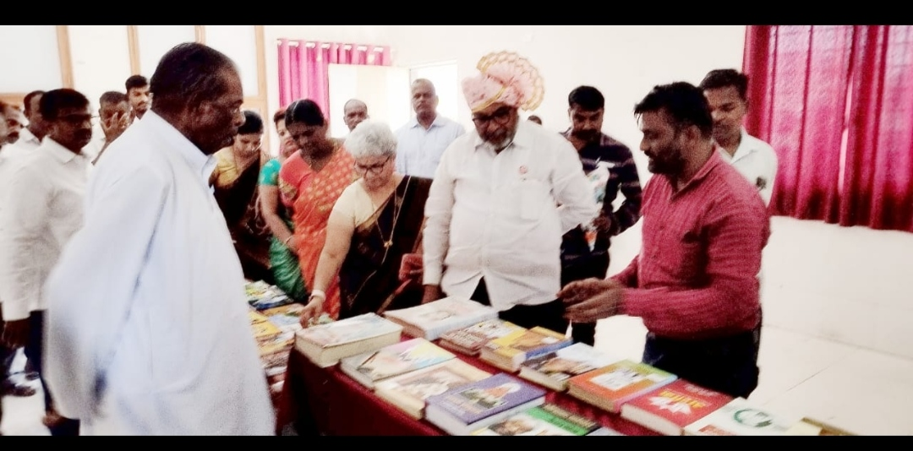
Name & Sign of the Report writer / Convener | Dr.Balaji A.Kamble  Mentor

Hon. Shri. Annasaheb Dange ACS College, Hatkanangale
Activity Report 2023-24

Name of the Activity with Date | Farmers meeting and honor ceremony  27/04/2023
Organizing  Committee | Committee
Aims and objectives of Activity | Silver Jubilee Year
Resource Person (Desig. & Office) | Hon.Dr.Vasantrao Jugale ,Ravsaheb Pujari  Chairman –hon.shri.Dr.Annasaheb Dange
Target Group &  Participant Number | Farmers
Brief Report  (4 to5 lines in English only) | Hon.shri. Annasaheb Dange Arts, Commerce and Science College's silver jubilee year farmers meeting and farmers' felicitation ceremony was organized on 27 4 2023 on this occasion Hon'ble Dr. Vasantrao Jogale discussed about modern agriculture and Hon'ble Raosaheb Pujari discussed how to do progressive farming. Annasaheb Dange gave valuable guidance to the farmers. Farmers from all the villages in the area were present in large numbers on this occasion
Supporting Documents | 1. Provide link of uploaded docs on College fb gourp  2 Portfolio File (Hard Copy
Geotagged Photographs  (1 or 2 only) | 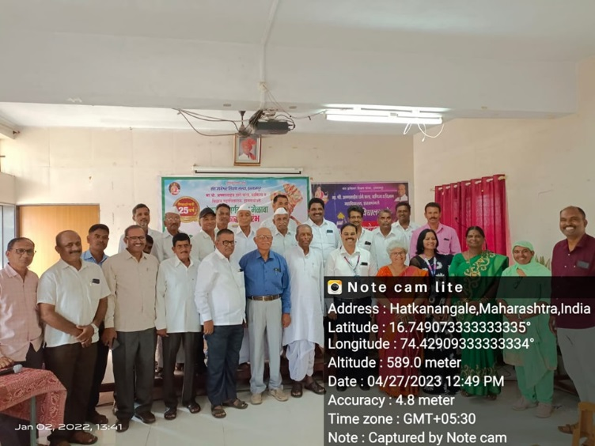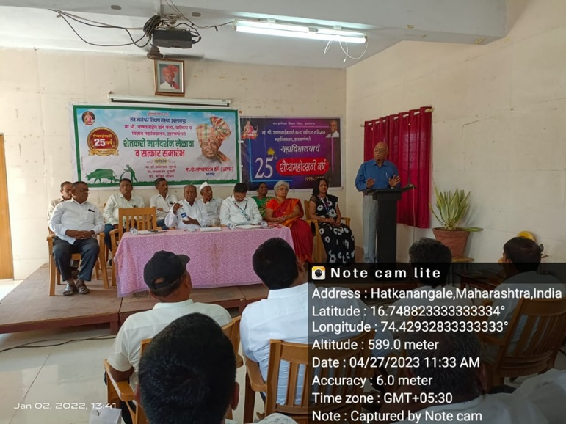
Name & Sign of the Report writer / Convener | Sri. S.D.Mohite

