HON. SHRI. ANNASAHEB DANGE ACS COLLEGE & ADACS ALUMINI ASSOCIATION HATKANANGALE
Activity Report (2022-23) Programme Under MOU

Name of the Activity with Date | Entrepreneur Conference (14 Dcember2022)  (Programme Under Silver Jubilee Year, NEP)
Organizing Committee | Commerce Department & Alumini Association
Aims and objectives of Activity | - To motivate students to become new Entrepreneurs.  - To Motivate & Manage of Small Start-Ups in India  3. To provide Working knowledge of entrepreneurship field.
Resource Person (Design. & Office) | - Hon Shri. P. M. Biradar. ( President of Engineer Association, Ichalkaranji/)  - Hon. Shri. Ksinath Jagdale ( Industrialist in Lakshmi Industries, Ichalkaranhi)
Target Group &  Participant Number | B.Com-III Students -65 & M Com -25 B. A.- 10.
Brief Report  (4 to5 lines in English only) | For the purpose of imparting the Entrepreneur Awareness, a programme is arranged. There were two entrepreneurs who have established small scale business was invited. They guided what are the initial steps in small start-ups and what are their challenges. They also guided students for purchasing procedure, Production procedure and Marketing in today’s world. They said that today is not a problem of production but problem of gutting customers & achieving their trust for our production is challenging So it is necessary to get the customer’s trust is key factor of any industry.
Supporting Documents | 1. Student Attendance Chart/Register (duly signed)  2. Provide link of uploaded docs on College website  3. Portfolio File (Hard Copy)
Geotagged Photographs  (1 or 2 only) | 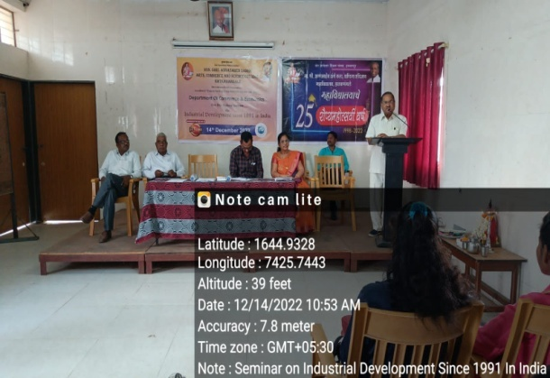  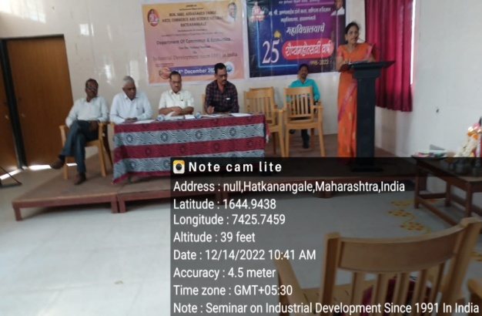
Name & Sign of the Report writer / Convener | Asst. Prof. Tandale Vandana Sanjay

