Hon. Shri. Annasaheb Dange ACS College, Hatkanangale
Activity Report 2023-24
रौप्य महोत्सवी वर्ष

Name of the Activity with Date | Farmers meeting and honor ceremony  27/04/2023
Organizing  Committee | Committee
Aims and objectives of Activity | Silver Jubilee Year
Resource Person (Desig. & Office) | Hon.Dr.Vasantrao Jugale ,Ravsaheb Pujari  Chairman –hon.shri.Dr.Annasaheb Dange
Target Group &  Participant Number | Farmers
Brief Report  (4 to5 lines in English only) | Hon.shri. Annasaheb Dange Arts, Commerce and Science College's silver jubilee year farmers meeting and farmers' felicitation ceremony was organized on 27 4 2023 on this occasion Hon'ble Dr. Vasantrao Jogale discussed about modern agriculture and Hon'ble Raosaheb Pujari discussed how to do progressive farming. Annasaheb Dange gave valuable guidance to the farmers. Farmers from all the villages in the area were present in large numbers on this occasion
Supporting Documents | 1. Provide link of uploaded docs on College fb gourp  2 Portfolio File (Hard Copy
Geotagged Photographs  (1 or 2 only) | 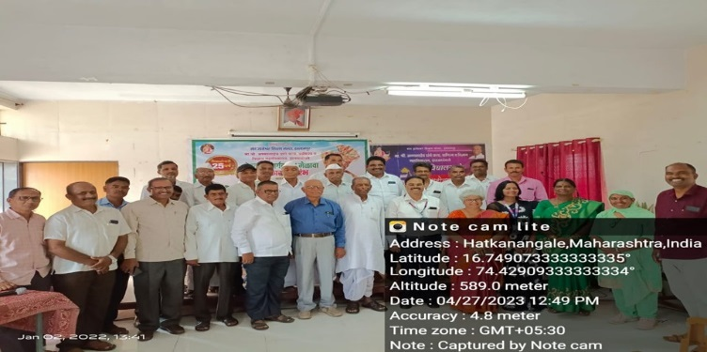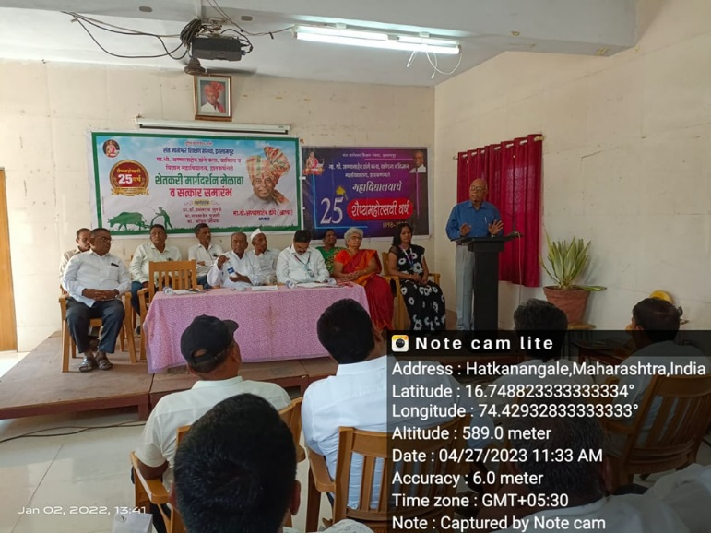
Name & Sign of the Report writer / Convener | Sri. S.D.Mohite

