Hon. Shri. Annasaheb Dange ACS College, Hatkanangale
Activity Report (2022-23)
रौप्य महोत्सवी वर्ष
Name of the Activity with Date | National Science day celebration on 28th feb 2023  Science Exebition
Organizing  Committee | Department of B.Sc
Aims and objectives of Activity | New trends in Science
Resource Person | Prin. Dr. Manjare sir
Target Group &  Participant Number | B.Sc. I, II, III students all departments
Brief Report | B.Sc department was celebrated National science day On 28th Feb 2023. Prin Dr.Manjare sir was chief guest for the function. The program began with poster presentation. . Chief guest Prin Dr.Manjare sir discussed and interacted with students to see student’s innovations in various science fields. Prin Dr.Manjare sir inaugurated function. Then poster presentation, project presentation given by students. Quiz competition was held by department. Coordinator of the science department Mr. P. S. Gurav sir has given welcome address. Mr Sahil Mujavar sir and Miss. Trupti Khot madam given speech. Mrs. Sarita Koli madam has given guest introduction. Chief Guest Prin Dr.Manjare sir gave the inaugural address and she shared his view about science and science learning and also about perusing science in higher studies. Presidential speech given by principal Dr. Yojana Jugale madam. The inaugural function was concluded with votte of thanks by Miss. Shruti Tare madam.
Supporting Documents | 1. Student Attendance Chart/Register (duly signed)  2. Provide link of uploaded docs on College website  3. Portfolio File (Hard Copy)
Geotagged Photographs | 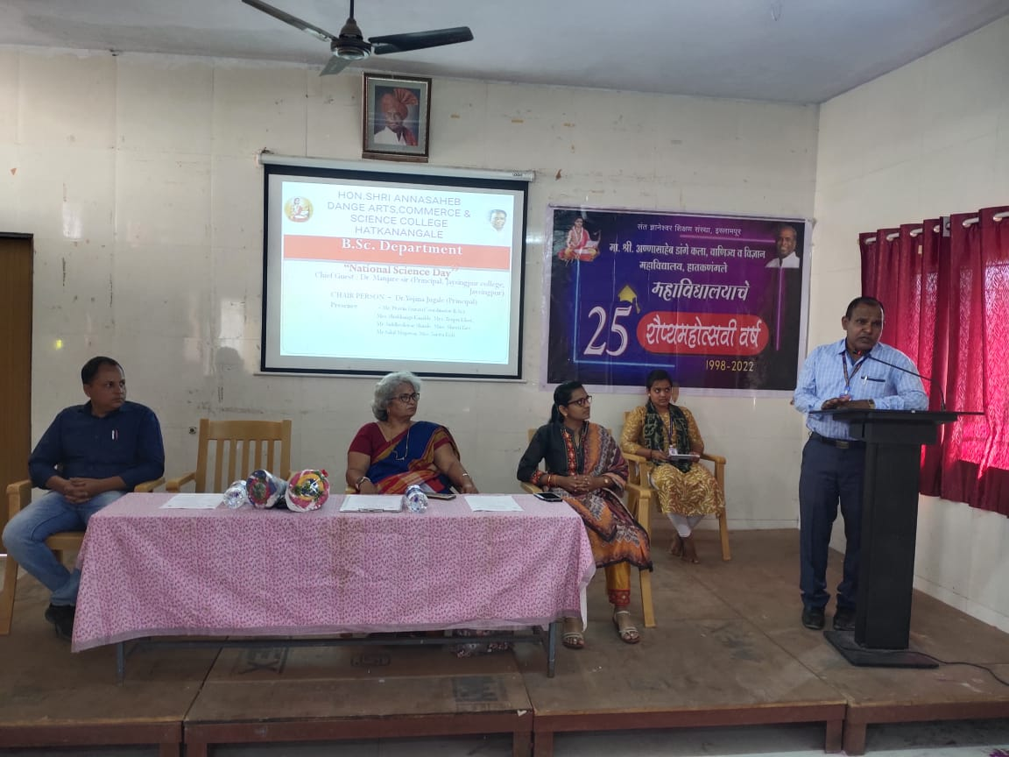
 | 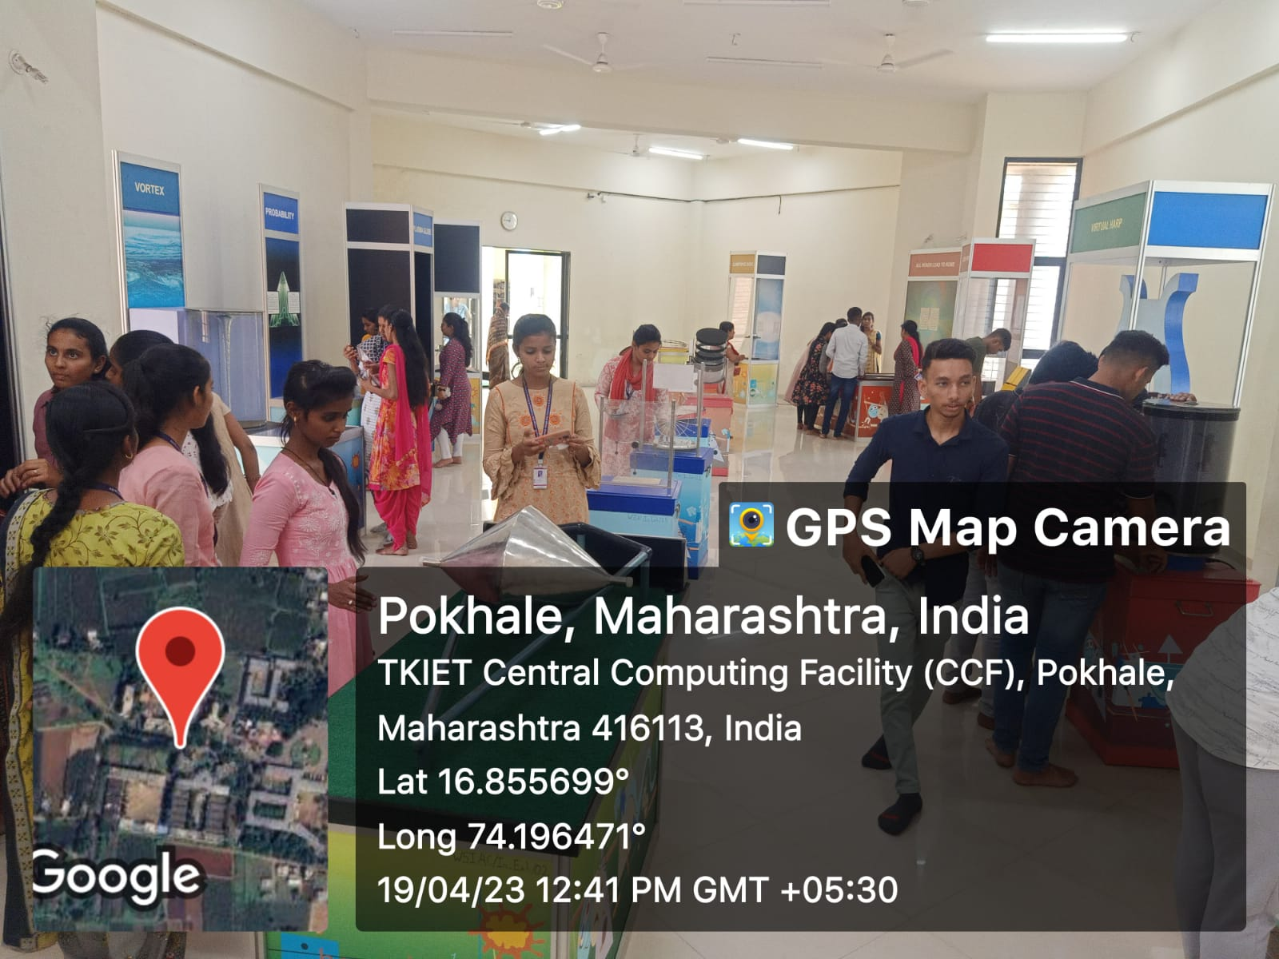
Name & Sign of the Report writer / Convener | Prof. Mrs. Sarita Pravin Koli

