Hon. Shri. Annasaheb Dange ACS College, Hatkanangale
Activity Report (2023-2024)

Name of the Activity with Date | Blood Donation Camp  Date: 7/07/2023
Organizing Committee | National Service Scheme-2023-24
Aims and objectives of Activity | 1) To students instill the feeling of helping others to breathe life  with a precious donation  2) To motivate to students to take to donate blood at least once in a year
Resource Person (Desig. & Office) | Shri. Ranjit Dhanagar, Vice-Precedent of  Hatkanangale Nagar Parishad
Target Group &  Participant Number | National Service Scheme Volunteers
Brief Report  (4 to5 lines in English only) | On 7 July 2023 under National Service Scheme organized Blood Donation Camp on the occasion of the Birthday of Hon. Snri. Annasaheb Dange. Hon. Shri. Ranjit Dhanagar, Vice Precedent of Hatkanangale Nagar Panchayat was chief Guest . Principal Dr. Yojana Jugale was the chairperson of this camp. Dr. Sunita Telsinge introduced the program. Dr. Sanghmitra Sarawade expressed a vote of thanks. Tota 52 donors donated blood. Students, citizens, teachers and volunteers participated in this camp.
Supporting Documents | 1. Student Attendance Chart/Register (duly signed)  2. Provide link of uploaded docs on College website  3. Portfolio File (Hard Copy)
Geotagged Photographs  (1 or 2 only) | 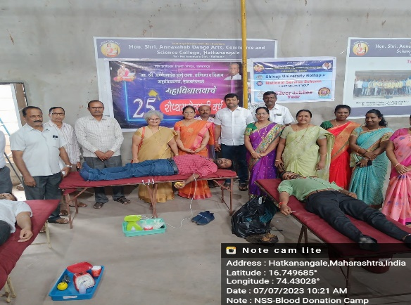  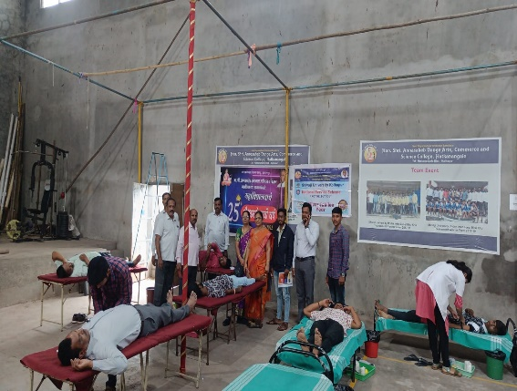  Participants  Inauguration: Shri. Ranjit Dhangar
Name & Sign of the Report writer / Convener | Dr. Sunita Shrirang Telsinge  Program Officer, National Service Scheme

