Hon. Shri. Annasaheb Dange ACS College, Hatkanangale
Activity Report (2022-2023)

Name of the Activity with Date | Har Ghar Tiranga  13 August 2022
Organizing  Committee | National Service Scheme-2022-23
Aims and objectives of Activity | to instill the spirit of patriotism in the hearts of people and to celebrate the Amrit Mahotsav of Independence with the spirit of public participation.
Resource Person (Desig. & Office) | ----
Target Group &  Participant Number | National Service Scheme Volunteers
Brief Report  (4 to5 lines in English only) | On August 13, 2022, National Service Scheme celebrated “Har Ghar Tiranga Abhiyan” on Amrit Mahostav Year of Independence. NSS volunteers distributed flags and help to villagers with Flag Hosting at their houses. NSS Volunteers and Dr. Amar Kamble, Dr. Vijay Dongare, Shri. Ravindra Patil, Shri. Ravindra Padavale, Shri. Ramesh Patil, Dr. Vikas Vidhate and other staff members participated in this Abhiyan.
Supporting Documents | 1. Student Attendance Chart/Register (duly signed)  2. Provide link of uploaded docs on College website  3. Portfolio File (Hard Copy)
Geotagged Photographs  (1 or 2 only) | 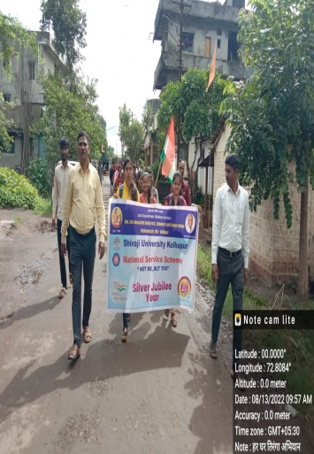  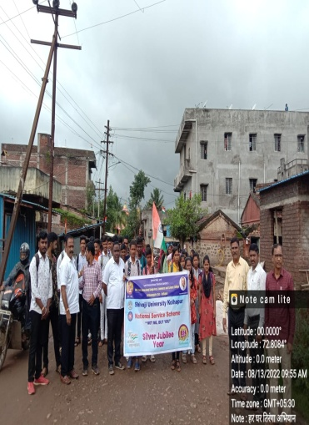  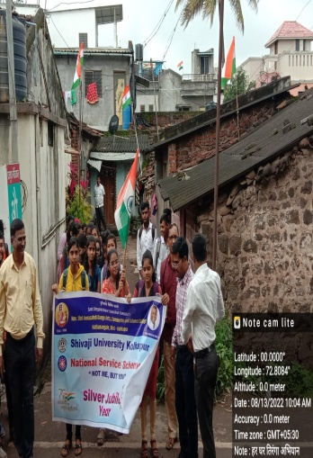  Participants of “Har Ghar Tiranga Abhiyan”
Name & Sign of the Report writer / Convener | Sunita Shrirang Telsinge  Program Officer, National Service Scheme

