Hon. Shri. Annasaheb Dange ACS College, Hatkanangale
Activity Report (2022-2023)

Name of the Activity with Date | Meri Mitti Mera Desh Campaign  Tree Plantation  Date: 23 August 2023
Organizing Committee | National Service Scheme-2023-24
Aims and objectives of Activity | To help promote sustainable living by reducing carbon emissions, mitigating climate change, and conserving natural resources.
Resource Person (Desig. & Office) | Mrs. Deepali Gondhali, Sarpanch, Nej -Shivpuri Grampanchayat, Tal. Hatkanangale
Target Group &  Participant Number | National Service Scheme Volunteers  Total Participants-
Brief Report  (4 to5 lines in English only) | On 23rd August 2023 National Service Schem implemented Meri Mitti Mera Desh campaign by Tree Plantation at Nej-Shivpuri, District Kolhapur. Mrs. Deepali Gondhali, Sarpanch, Nej-shivpuri Grampanhayat planted trees. Dr. Sunita Telsinge, Dr. Sanghmitra Sarwade and NSS volunteers participated in this campaign.
Supporting Documents | 1. Student Attendance Chart/Register (duly signed)  2. Provide link of uploaded docs on College website  3. Portfolio File (Hard Copy)
Geotagged Photographs  (1 or 2 only) | 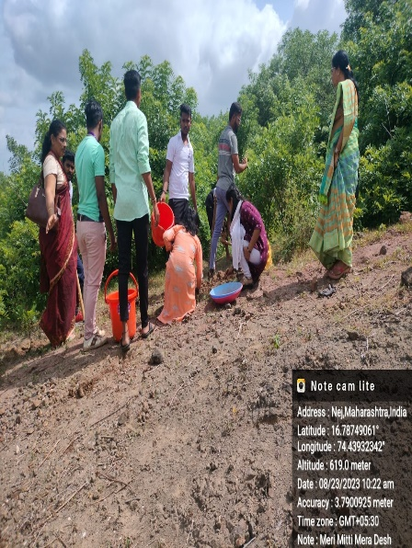  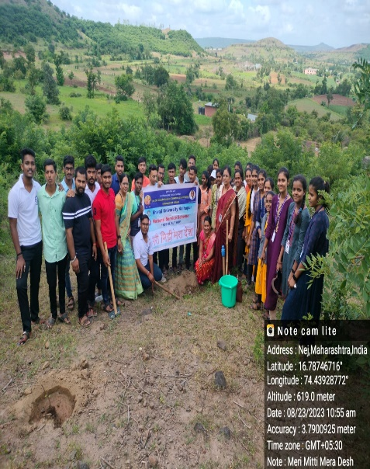  Tree Plantation at Nej
Name & Sign of the Report writer / Convener | Dr. Sunita Shrirang Telsinge  Program Officer, National Service Scheme

