.
Hon. Shri. Annasaheb Dange ACS College, Hatkanangale
Activity Report (2022-23)

Name of the Activity with Date | Subhdrabai dange Death Anniversary 17 Jan 23
Organizing  Committee | Cultural Comittee
Aims and objectives of Activity | To make awarrness about social Resposibilities amng students.
Resource Person | Hon Hiratai Musai
Target Group &  Participant Number | College Faculty and students  100 Students Participate
Brief Report | laLFkk ekrk ekrksJh lqHknzkckbZ Mkaxs ;kaP;k Le`rh fnukfufer fn 17 tkusokjh 2023 egkfon;ky;kP;k iapdzksz”khrhy loZ fujk/kkj o xjtw efgykauk enr okVi dk;Zdzekps vk;kstu dj.;kr vkys- xjTkw efgykauk izR;sdh jks[k 2500: enr ek-fgjkrkbZ eqlkbZ eWMe ;kaP;k gLrs dj.;kr vkyh ,dw.k 50 efgykauk enr dj.;kr vkyh-
Supporting Documents | 1. Student Attendance Chart/ List  2. Photograph
Photographs | 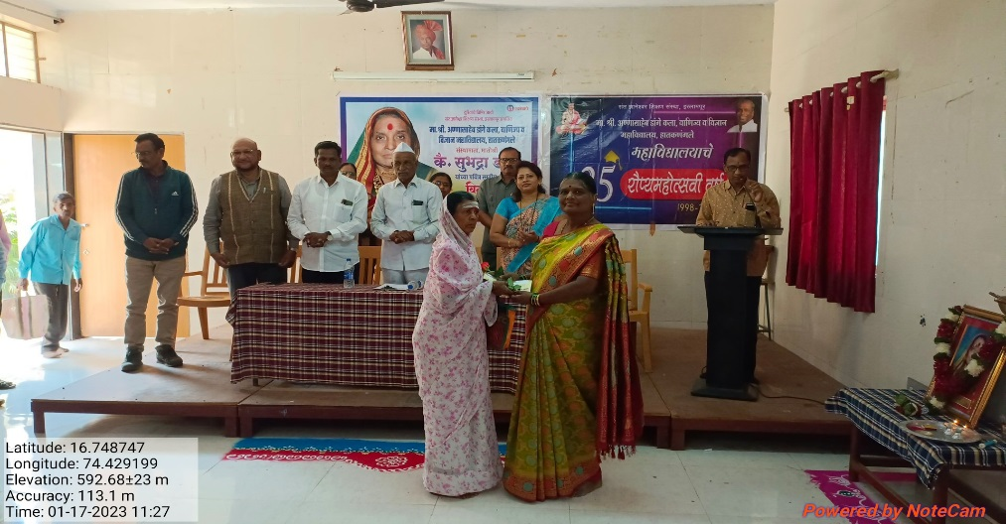
Name & Sign of the Report writer / Convener | Dr.Mohan Sawant

